# Sirmione & Florence: Ruins, Legends, and Art

The day after we got home from our weekend trip into the Dolomites, I traveled to nearby Verona with our friends, Rich and Andrea Garner. Rich was especially excited to see the Arena di Verona, a large colosseum similar to the one in Rome, but this is a smaller and even older version! We made a plan where I would drop them off near the Arena and they could wander and enjoy on their own for a bit, while I drove myself over to the mall, about 10 minutes away (tee hee).

I have already visited the Arena twice, and have been to Verona a few other times, as well. So, I preferred to do a little shopping this time instead. As I dropped them off on the busy street and watched them walk away, I felt a little bit like a mom, ha ha. It was a feeling of pride, mixed with a little bit of worry as I drove away. (What if something happens and we can't get ahold of each other?)

I had taught them how to use the crosswalks, and yes, I know it sounds weird to say that, but there is a lot of structure to the pedestrian "rules" in Italy. You are safe 99% of the time in a crosswalk, instead of jay-walking like we do in the U.S.  And even when you're walking along a paved path or sidewalk, often there are painted lanes for pedestrians vs bicycles and it's really important that you stay in your assigned lane.

We had practiced using Google Maps together, and I showed Rich how to send me a "pin" of his location so that I could pick them up just about anywhere 2 hours later. We had a loose plan and we had a contingency plan, as well.

Scott had also set them up with an extra phone that has an Italian SIM card in it. This allows them to have better access to the internet when they're away from the house. We emphasized the need to use WhatsApp for communication, too. It just works better than regular messaging over here, and everyone uses it, including restaurants and other businesses.

So off they went . . . and away I drove.

I found a few things at the mall that I needed, and they had a great time exploring the Arena, the nearby Castle, and some surrounding streets. I picked them up at the same place where I had dropped them off earlier, and all was well. I don't mean to suggest that they were incapable of walking around a new city in Europe by themselves . . . but I was coming from a perspective of "Hey, you guys are my friends and I don't want anything bad to happen to you." (I'm also a natural worrier, so . . .)

Next, we drove over to Sirmione, about 45 minutes west of Verona. Sirmione (pronounced: seer-mee-OH-nay) sits on a long, narrow peninsula along the southern edge of Lake Garda. It's a very cute town. I hadn't been over there for a while, so it was fun to see it again.

We had some trouble finding parking - which I thought to be unusual since it was a Tuesday morning in early October . . . We drove around and around for maybe 20 minutes or more before we found a spot to park, and thankfully it wasn't too far from where we wanted to be.

The castle in Sirmione is known as Castello Scaligero di Sirmione. We didn't go inside for a tour this time because Rich and Andrea had just visited the castle in Malcesine with us, and didn't feel a need to do another castle tour. We enjoyed watching the swans swimming around in the moat for a few minutes before moving on.

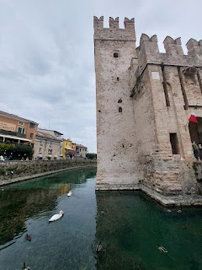

Short video of the swans-a-swimming: (7 seconds)

https://photos.app.goo.gl/gTg5bHFyvT8hxLfF6

There are several streets and alleyways next to the castle to wander through and window-shop. It can be a bit crowded in this area, as it was on this particular day, which can take away from the enjoyment somewhat. But if you look up, you'll find little treasures like the wisteria on the front of this building.

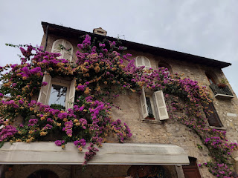

We settled on a little restaurant called "Cristallo," located less than 5 minutes on foot from the castle. I ordered a bruschetta pizza with 2 types of thin meats on it, cheese, and mushrooms. It was very good!

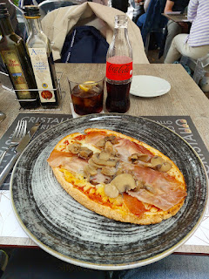

Next, we made our way to the Roman Ruins of Sirmione, something I had NOT seen before. I was really excited for this place! The actual name for it is: Archaeological Site of Grotte di Catullo. It includes the ruins of an ancient villa, an equally old olive grove, and an archeaological museum.

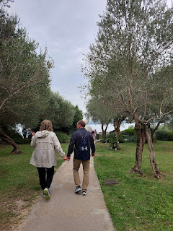

There is a public park you can walk through on your way to the Roman Ruins. It has some paths that also lead down to a public beach on the eastern side of the peninsula.

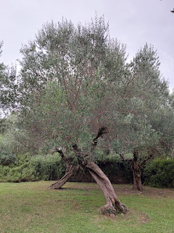

The olives are coming up on harvest time!

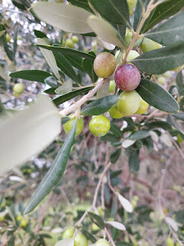

Something we learned by the end of our visit to the Roman Ruins is that if you would rather spend more time traipsing around the actual ruins OUTSIDE, then don't get too sucked into the black hole of the museum INSIDE. We spent too much time reading and looking at and trying to absorb information in the museum portion, and then we were running out of time to spend in the best part - which were the ruins themselves.

Nevertheless, there were some interesting items inside the museum, like these Bronze Age utensils . . .

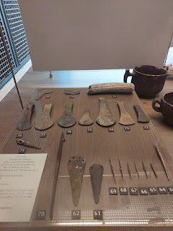

And pieces of pottery, along with the ancient grain known as millet (in the petri dish containers below), a cereal that the Italians used.

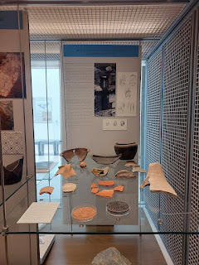

Sorry for the wonky photo of the sign below, but the lower portion says: "The analysis of the botanical remains found inside the small drainpipe in a cleaning phase during the destruction of the building (end of the 5th, beginning of the 6th century), have produced very interesting pieces of information. A large quantity of Italian millet (foxtail millet) and millet seeds was discovered. These cereals played an important role in the diet of of the late Roman period and at the beginning of the Middle Ages. The presence of sorghum is attested too. The sorghum is a cereal which was, so far, known only in the Middle Ages and medieval finds, even if it was used in Roman times, too."

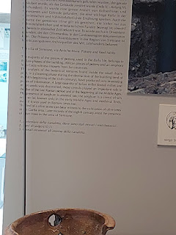

This next photo explains the dating of the Villa, whose ruins we were about to explore. At first, the Villa was dated to be from the 4th century AD, but later it was adjusted to reflect the 1st century.

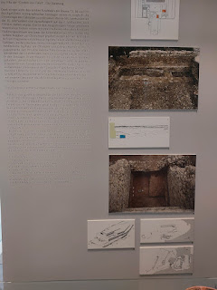

Cups and fragments of cups from the 1st century . . .

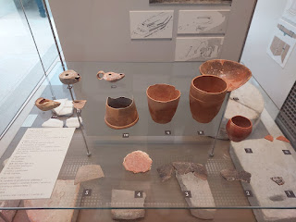

Here are a couple different views of what is believed to be the original design of the Villa . . .

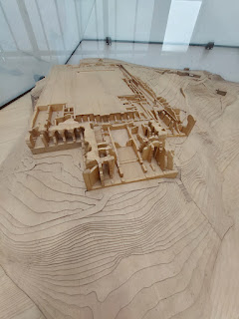

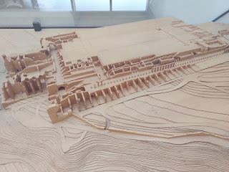

I thought these handpainted pieces were very handsome, even if they were all broken apart.

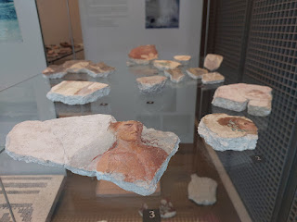

Yay - we made it outside. It was a fascinating place to explore . . . (and that's me in the photo below)

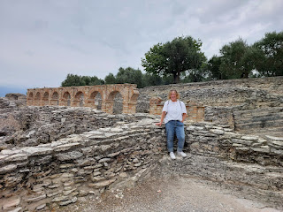

I found it a bit odd, but also intriguing as to why these bright plastic wolves would be placed here.

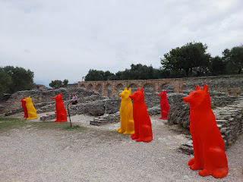

In ChatGPT (an AI tool), it said:

"They are likely part of a contemporary art installation by the Italian artist Cracking Art, a group known for placing large, vibrant plastic animal sculptures in historic or urban settings. This is done across many locations, using art to spark dialogue about the environment, the relationship between humans and nature, and sustainability. The plastic wolves specifically evoke themes of wildlife, power, and adaptability, creating a contrast between ancient ruins and modern environmental issues. Sirmione, with its rich Roman history, is an ideal setting for this type of juxtaposition, as the modern, brightly colored sculptures stand out against the historic stone ruins, drawing attention to the fusion of past and present."

Below: Looking north, in what used to be the main "Promenade", an ancient recreational walking trail of sorts. The elevated path was built for the family members to have a peaceful and tranquil place to exercise. There were alcoves along this path that led to the sea, presumably stocked with flowers or artistic arrangements, which could give a reason to pause for the person walking along, offering something beautiful for them to stop and observe.

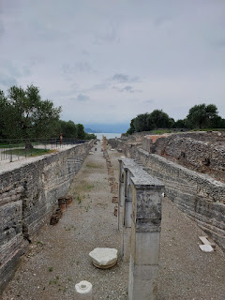

The thermal baths . . .

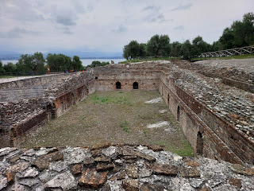

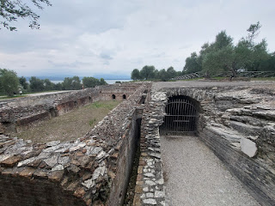

Explanations of the thermal baths . . . (click photos to enlarge and read)

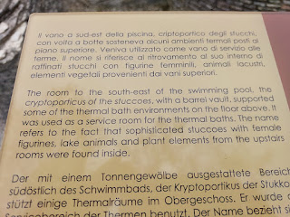

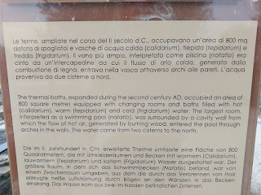

I got such a KICK out of the shapes of the ancient olive trees! So much so, that I started taking several photos to make into an album to share with my daughter, Amber. She has offered to paint me a couple of paintings - of whatever I want - and I've narrowed my wish list down to two things: an olive tree or orchard, and a painting of Jesus running in "relentless pursuit" of one of His precious lambies.

Here are a few of my favorite shapes of the olive trees . . . (picture them as humans - dancing, LOL)

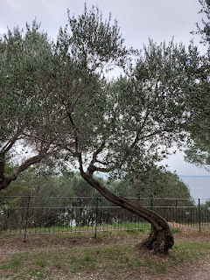

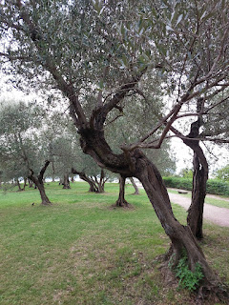

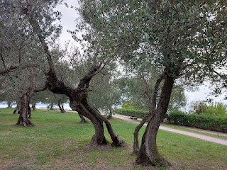

From the Villa and overlooking Lake Garda, looking north.

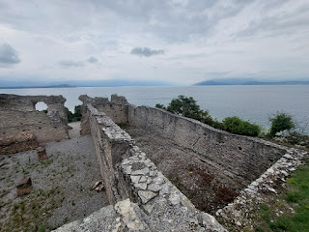

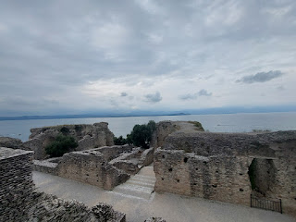

From a photographer's point of view, this place was a jackpot of all the epic jackpots. I had so much fun trying to capture various moods, details, and perspectives.

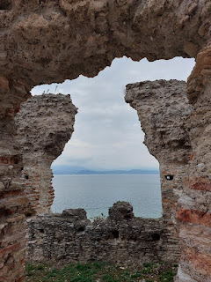

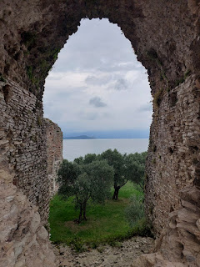

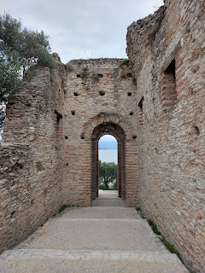

Video as I walked down the long path toward the view of the Lake: (39 seconds)

https://photos.app.goo.gl/qfcnDMomrR2xDub58

Another short video of one of the many paths on the property: (13 seconds)

https://photos.app.goo.gl/7HkaTduDF3wiUNED9

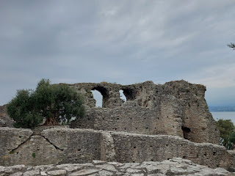

Down below the Villa is a beach known as Jamaica Beach. Scott and I have walked around the entire tip of the peninsula before, by ourselves, and again with his brother, Gordon and his wife, Pam last spring. There has been so much rain this fall, that the entire beach is underwater right now. I'll show you both perspectives - - -

This is now . . . with the whole beach under water . . .

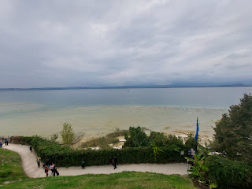

And this was 18 months ago in April 2023 . . . from Jamaica Beach, looking up toward the Roman ruins.

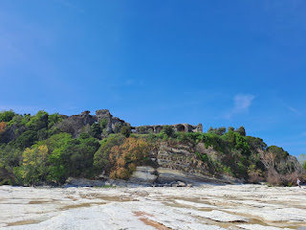

Scott is seen walking quite a ways out on the beach . . .

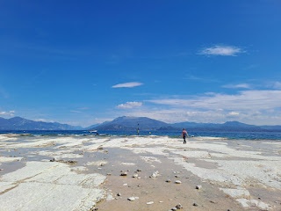

What a difference between that trip and this one!!

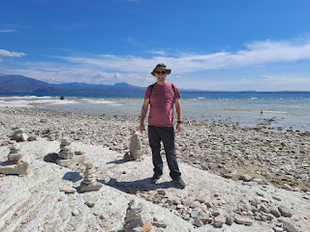

An explanation near the exit on how there are teams of gardeners trying to correct a bacteria that is growing on some of the ancient olive trees . . . (click photos to enlarge)

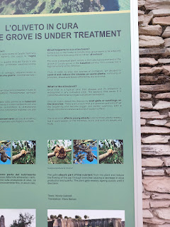

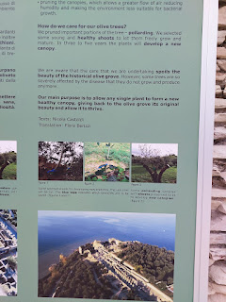

We needed to get back to Vicenza so we could make dinner and spend some time with Scott before he went to bed (he goes to bed early because he gets up super early). He was already home, and we were over an hour away still. I had a funny thought pop into my head as Andrea and I tried hard to get Rich away from the Roman ruins, something we thought we'd never be able to do, ha ha. Remember those old cartoons where, when someone was on stage, and the stage hands wanted to get that person off the stage as quickly as possible? What did they do?

They used a cane to yank that person right off the stage, ha ha.

That's what it felt like in order to get Rich out of there . . . lol. He could have spent 12 more hours among the ruins, but Andrea and I were like, "How are we ever gonna get him out of here?" So, basically, we did the cane yank and then we drove home.

Plus, we needed to get ready for a big adventure early the following morning.

FLORENCE (Day One):

I had a horrible night's sleep - because whenever there is something big in the plans for the next day, my brain has a hard time relaxing. Instead, I have to go over all the details coming up instead of sleeping. I began my day with only about 3.5 - 4 hours of sleep during the night.

Scott drove us all to the train station and dropped us off, and then he went to work. The train took us to Padova first, where we switched to a larger and faster train, and then we rode all the way down to Florence. We booked our tickets together on the app "Omio" (my favorite), but I ended up in a seat next to some guy, while Rich and Andrea at least got to sit together across the aisle. I was glad I had brought my neck pillow with me, because I knew I would need it after that crappy night of sleep.

Rich and Andrea said that I even snored a couple of times . . . ha ha.

I really needed that extra rest, and I'm so grateful that I had the chance to grab it. The total travel time was about 3.5 hours. I was in a deep "rest" most of that time. I could hear sounds and conversations going on around me, but they sounded really far away with my eyes closed. And I remember the train being stopped a couple of times, out in the middle of nowhere. I remember hearing an announcement through the speakers, letting us know that we were stopped briefly because of train "congestion" and that they couldn't pull into the station just yet.

Rich gave me a little more perspective later, when he told me that one of the times we sat there, it was for a whopping 55 minutes!! I was shocked because in my sleepy stupor, I thought it was only about 10-15 minutes. Sometimes there are public transportation strikes and there are limited (or even zero) trains or buses running. Usually this is all publicized well in advance, so passengers can plan accordingly. I'm not sure if a strike was going on at this time or not, but it took us a lot longer to get into Florence. It's a good thing we had a loose schedule for that day or we would have been in trouble if we had had tickets for something important!

Once we finally arrived at the Santa Maria Novella Station in Florence, Rich guided us to our AirBnB, roughly a 15 minute walk. What a cute place - and very centrally located.

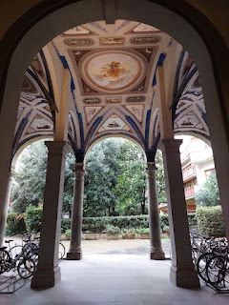

My room was up in the loft above. It was very cozy and comfortable. Rich and Andrea had a bedroom down below, and we had one bathroom to share and a nice sized kitchen, too.

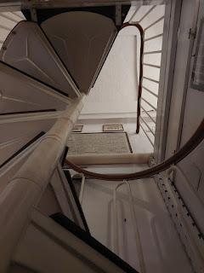

We set out on a walk toward the Ponte Vecchio Bridge, knowing that there would be several points of interest along our way. True to form, we passed by the Basilica of Santa Croce (pronounced "Croh-chay"), which was on our wishlist of things to visit while we were there.

Here is a link to a great website that offers details about the church:

https://www.visitflorence.com/florence-churches/santa-croce.html

Essentially, it was built in 1294 and houses the "great and good" in Florence. Several famous people are buried here, including: Michelangelo, Galileo Galilei, Gioachino Rossini (the composer), and Niccolo Machiavelli (an author).

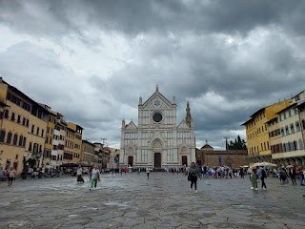

From where we stood, looking toward Santa Croce, I noticed a building on the right that looked strikingly familiar. In the photo just below, note the long building in the middle. The frescoes on the outside, as well as the actual paint tone itself, reminded me a LOT of the house where my Bassano ancestors used to live in Bassano del Grappa.

The Florence building . . .

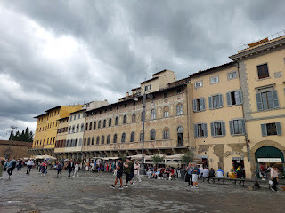

The Bassano House in Bassano del Grappa . . . YOU SEE WHAT I MEAN??

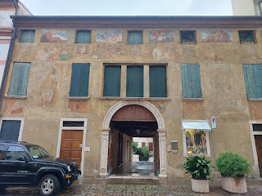

Back to the Basilica of Santa Croce: We did pay a small fee to enter (8 euros each). It was worth every penny.

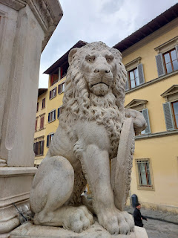

The feetsies of me, Rich, and Andrea inside the Basilica . . .

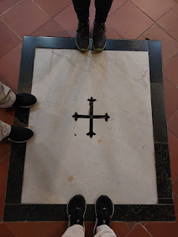

The inscription of Galileo Galilei's tomb . . . mentioning his expertise in Geometry, Astronomy, and Philosophy. He was also a physicist and an engineer. He died at the age of 77.

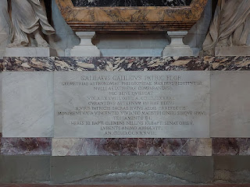

The memorial surrounding his tomb . . .

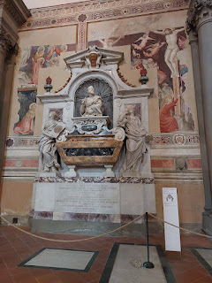

This is the memorial for Michelangelo . . . very beautifully crafted.

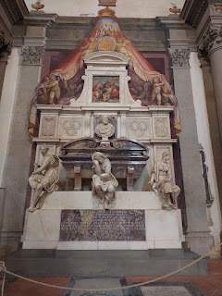

Below the grieving angel are the words (translated from Latin): "Michaeli Angelo Bonorotio. From the ancient family of the Simonians - sculptor, painter, and architect. Ever known to all as Loving Uncle Leonard. And with great merit, his bones were transferred from him and buried in this great temple in the great sepulchre."

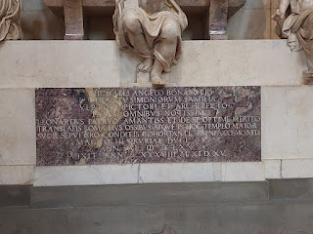

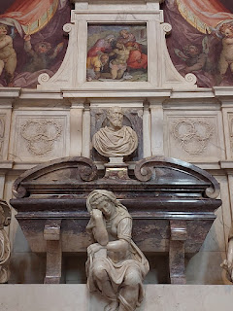

The sculpted angel and other figures were made from white cararra marble. Michelangelo lived from 1475 - 1564.

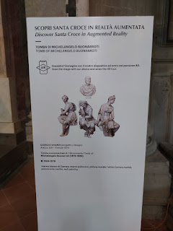

A beautiful painting of Christ on the Cross . . . (I didn't catch who the artist was)

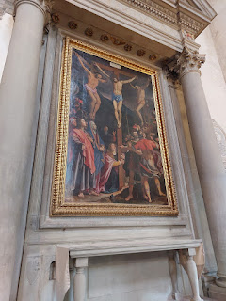

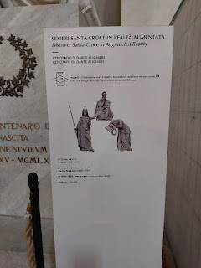

Above and Below: Dante's memorial tomb - but it's empty . . . He lived from 1265 - 1321.

Sadly, he was exiled from Florence and was buried in Ravenna. According to the website link I provided above (for the Basilica), Dante was an "incredible Tuscan poet" who was "exiled from Florence for his political activities in 1302 and was not allowed to return." And, "even though they are clamoring to have his physical remains returned, they still haven't forgiven him for his 'indescretion'."

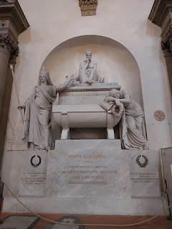

Per Chat GPT:

"Dante's 'indiscretion' was that he opposed the Pope and certain policies that were being enforced around the year 1300. He was charged with corruption, financial wrongdoing, and opposing the Pope, largely as a result of

[one Florentine group's]

manipulation of power. He was sentenced to exile and faced execution by burning at the stake if he ever returned to Florence. This forced him to spend the remainder of his life wandering throughout Italy, never returning to his beloved city.

"Though the charges were politically motivated, the real 'indiscretion' in Dante's case was his involvement in the political struggles of Florence and his opposition to the papal party. This exile deeply influenced his writing, particularly his masterpiece, the Divine Comedy, where he often reflects on the corrupt politics of his time."

This incredible carving below was made by Donatello in 1433-1435. It is entitled, "The Tabernacle."

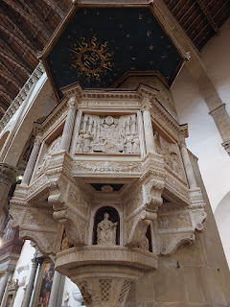

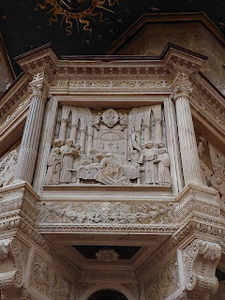

While I didn't take photos all the way around, it was still very profound. A description is given on the sign below. (click photo to enlarge)

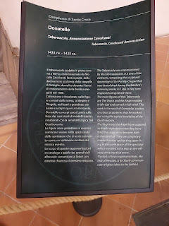

I assume that these tombs that lay in the main floor of the Basilica were for people of some importance. They are not marked, most of them, and those that do have markings are either too faded to read or they are in Latin. I tried to step around each one instead of stepping directly ON them . . .

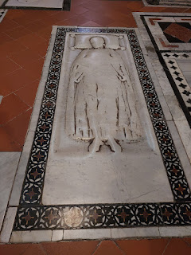

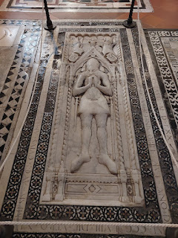

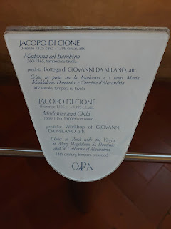

A beautiful gold-leafed painting (below) of the Madonna and Child in Pieta (pity or compassion). The artist, listed above, was Jacopo di Cione. This careful painting on wood was made between 1360-1365.

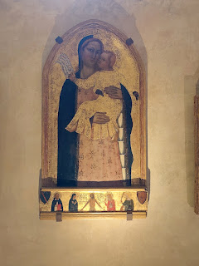

Galileo was first buried in this smaller room, tucked further back in the Basilica, but later he was moved to the more prominent location that I shared above.

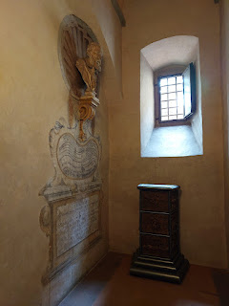

A bust of Galileo . . .

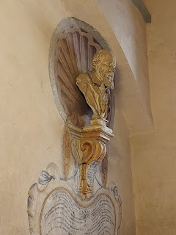

I thought of my niece, Mari, when I saw this scene, and I sent the photo to her. She has the desire to return to her Catholic roots (through her father's line) and wants to learn better how to pray. I've been messaging back and forth with her from time to time about these things, and I knew she would love this photo. It evokes a sense of peace and love and comfort.

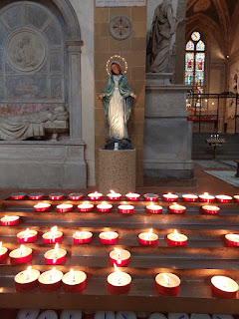

Outside the Basilica, I wanted to capture some perspective on just how big the structure is. While this photo doesn't show the entire stature, you can see a portion of how big it is compared with how small the lady is as she walks past . . .

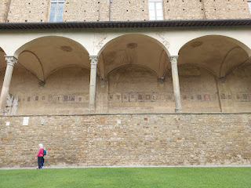

Our tummies were hungry after we left the Basilica, so we went in search of food along our route to the Ponte Vecchio Bridge. We kept passing people with huge sandwiches in hand, some impromptu advertising, ha ha. We ended up asking a group of young men who were sitting down and wolfing down their sandwiches, where did they get their food? They pointed to a side street and said, "Down there."

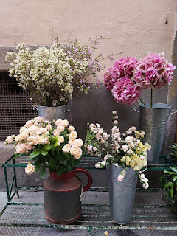

We found the place alright. There was a line out the door of hungry people just like us! The restaurant is called "Schiacciateria de Neri 18". They make everything themselves, including the bread.

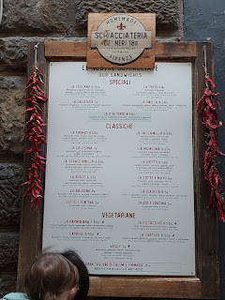

They not only offer a menu describing what's in each sandwich, but they also place examples of each type in a glass case as you enter the cramped shop. This poor young couple were seated at a tiny table for two in front of the entrance, with the hoards of customers bumping into them and breathing all over them as they ate their lunch . . . poor things.

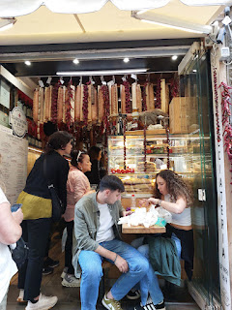

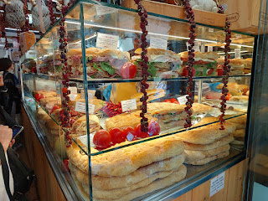

Once you order a particular sandwich, it gets passed down the line to someone running the large toaster oven at the back, where the sandwich is heated up perfectly before being handed over to you to enjoy.

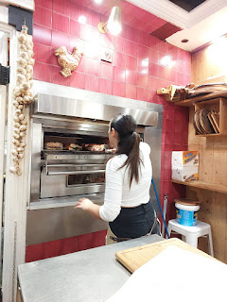

We found a quiet place to sit and eat our giant sandwiches just a couple of streets over from the restaurant. The River Arno was directly behind us.

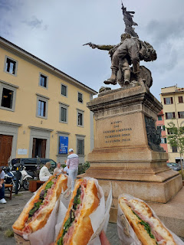

Each sandwich is essentially TWO sandwiches because of their size. Thankfully, we had a man in our midst, who dutifully ate the other halves of both mine and Andrea's sandwiches, ha ha.

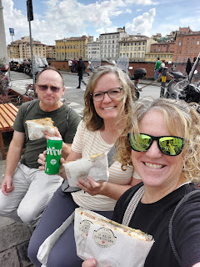

With bellies full to the brim, we walked along the river toward the Ponte Vecchio Bridge.

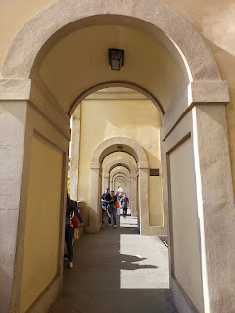

The Bridge was completed in 1345 and was an outstanding engineering masterpiece of the Middle Ages. It is the oldest stone bridge in Europe and was the only one in the area to be miraculously spared during WWII.

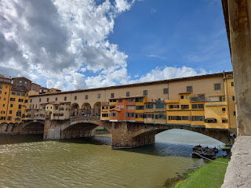

Built not only to connect townspeople on both sides of the impressive Arno River (which was prone to massive flooding), the Ponte Vecchio also became a place of shopping for the passersby. In ancient times, the shops were built off the sides of the bridge so as not to interfere with the "road" itself, and were supported by stakes and beams over the river. (Can you even imagine?) For a very long time, many of the shops were run by butchers and fishmongers who would toss their scraps and unwanted waste into the river below. Eventually, the smell was no longer tolerable and so a change began to take place. More reputable shops were created instead, leading up to the FANCY shopping experience that you will find today.

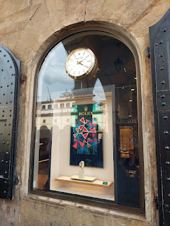

Jewelry is the main attraction on the bridge today, with each storefront window offering a unique display of colors and designs that differ only slightly from the shop next door. Rolex watches, rings, necklaces, etc. are in abundance here. There are a few leather stores mixed in with all the jewelry, too.

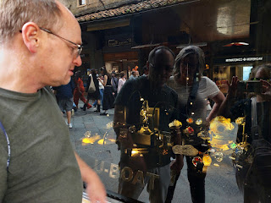

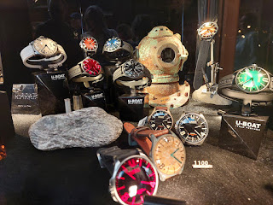

Andrea, Rich, and me on the Ponte Vecchio Bridge, with the river flowing northwest behind us . . . the Arno River eventually dumps out into the Ligurian Sea at Pisa (to the west). The Ligurian Sea is part of the Mediterranean Sea.

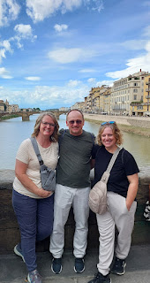

An unexpected discovery on our walk was this beautiful sculpture . . .

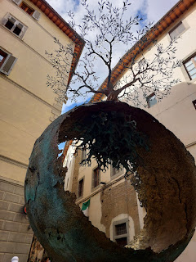

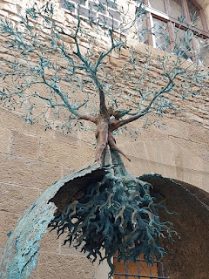

I used Google Translate to understand what the significance of this was . . .

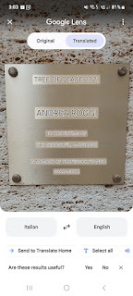

Per Chat GPT (with some paraphrasing):

The Georgofili Massacre was a tragic bombing that took place in Florence, Italy on 27 May 1993. The attack was carried out by the Sicilian Mafia as part of a broader campaign of violence against the Italian state. The bombing targeted the Accademia dei Georgofili, an important cultural and academic institution located near the Uffizi Gallery.

In the early hours of May 27th, a Fiat Fiorino van packed with explosives was detonated nearby. The explosion severely damaged nearby buildings, including the Uffizi Gallery and destroyed irreplaceable artwork. The blast killed 5 people: a police officer (Fabrizio Nencioni), his wife Angela, their two daughters (Nadia - 9, and two-month-old Caterina), and a student named Dario Capolicchio. Dozens more were injured and the damage to the historic center of Florence was extensive.

The mafia's motivation was in response to the Italian government's increasing crackdown on organized crime. Several top leaders of the Mafia had already been arrested and convicted, so the Mafia carried out a series of retaliation bombings in Florence, Rome, and Milan, targeting cultural and civilian sites. (How thoughtful of them)

Those who were behind the orchestration of these attacks were soon found and convicted for their crimes.

I'm so glad that this masterful and peaceful sculpture caught our attention in the alley near the Uffizi Gallery. Once I understood what (and for whom) it was made for, I stood there for a long time, pondering the symbolism of it. Life is truly bigger than the moment we are currently in. We need some very deep roots to anchor us in times of tragedy and turbulence. These roots can be in the form of family, friends, prayer, and of course, our Savior Jesus Christ. We can also find moments of joy and peace as we strive to rise above the darkness of bullying, war, disaster, and death.

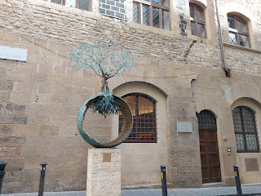

The Uffizi Gallery is HUGE and we had researched it ahead of time, opting to NOT go inside on a tour this time. From what we had read online, you can spend several hours here, and we just did not have that much time to spare. Especially when Rich and Andrea were already planning to visit the Accademia to see Michelangelo's David statue the following morning, which would include a lot of artwork inside that gallery, too.

So, instead, we slowly walked past several pieces of art that sit OUTSIDE the Uffizi Gallery, which was very enjoyable (and free).

This is a statue of Leonardo da Vinci, who was from the Florence area. He grew up in a town nearby named "Vinci".

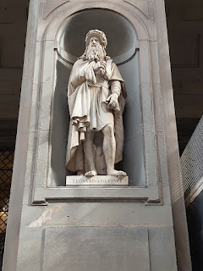

We saw a few local artists hard at work, creating detailed paintings while crowds of people passed by.

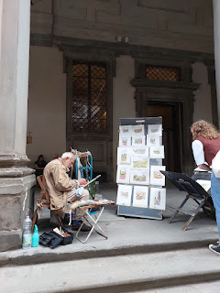

There is a lot of symbolism in the statues just below . . . including some Greek and Roman mythology, among other legends, and they usually involve someone conquering someone else of status and importance.

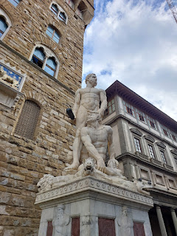

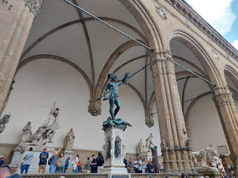

I particularly liked the lions . . .

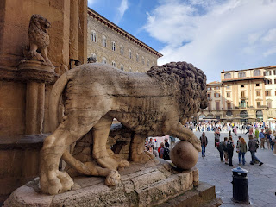

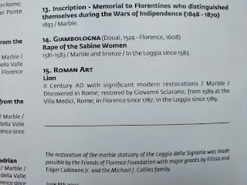

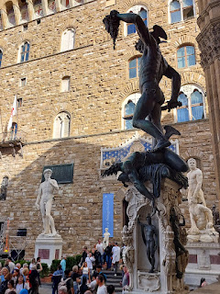

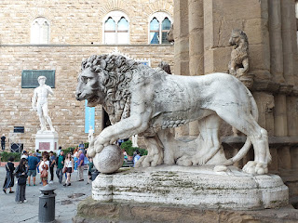

Andrea and I sat on a bench that lined the wall in front of the lions for quite a while, as Rich wandered through the "outdoor" gallery behind us. It felt so nice to just sit and be still for a time, watching all the other people stop to take photos of everything around us.

Video of the outdoor gallery where we sat: (16 seconds)

https://photos.app.goo.gl/8doo3AbiCtsUb1kr6

This is a famous fountain outside the Uffizi Gallery, known as the Fountain of Neptune. It was commissioned by Cosimo de Medici I in 1559 to celebrate the marriage of Francesco de Medici I to Grand Duchess Joanna of Austria.

The fountain consists of a giant Neptune atop a shell-shaped horse-drawn chariot, along with Tritans, Satyrs, two young women with Putti (or cherubs), two young men with dolphins, and Fauns.

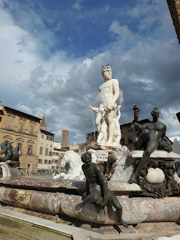

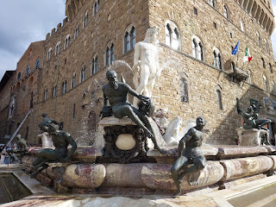

Video of the Fountain of Neptune: (7 seconds)

https://photos.app.goo.gl/AoUSDLYTkAK56VkaA

On our way back to the AirBnB (for a much needed time-out), we saw what at first looked like an adorable lion on his hind legs saying "Rawr". But on closer examination, in his mouth he has the head of the person who lies pathetically at his feet . . .

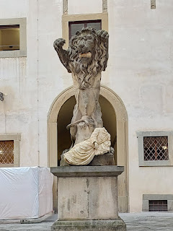

After a nice hour-long rest in our respective beds, we set out for another round of sightseeing. We had tickets to visit the Duomo and Tower, and it was a short walk from our AirBnB (maybe 5 minutes or so). We decided that climbing up the tower first would be a good idea because it looked like it was going to rain soon, and we figured that we could go inside the Duomo later when the rains hit.

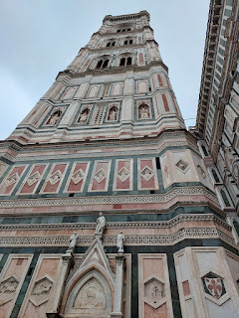

We hit a snag when we moved up the line to enter the Tower, though. The girl checking our tickets informed us that we could not go up with our backpacks on and that we would have to "check" them. This was troubling because some people were exiting from the previous tour group - right in front of us - and many of them had similar cinch sacks on their backs and had been allowed to go up. I mentioned this to her, but she would not budge on her stance. It's possible that another worker had loosely allowed those individuals to enter with their backpacks and cinch sacks on, but clearly that was not something she was willing to do.

Frustrated, but still willing to comply, Andrea held our place in line while Rich and I ran across the huge plaza, around and behind the massive Duomo, to the coat and bag check-in place. As we handed off our stuff, the young man informed us that we needed to pick up our belongings by 7:00 because that's when they closed. Okie dokie. And then we ran as fast as we could back around to the Tower and to where Andrea held our spot. The young woman politely let us go through this time.

You can see a portion of the magnitude of the Duomo and its connecting buildings in the photo below. It was no small feat to get over to the check-in place for those cinch sacks of ours . . .

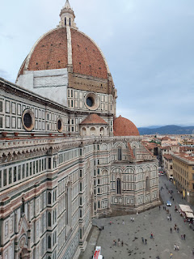

The Tower is known as Giotto's Tower because the famous architect for this epic project was none other than Giotto. Construction began as early as 1334, but was later handed off to others to finish the work because Giotto passed away. It was finally completed in 1359. It is 84.7 meters tall (277 feet) and 15 meters in breadth (49 feet). To get to the top, you must first climb the 414 steps. Challenge accepted.

Video from the entrance looking up to the top of the Tower: (8 seconds)

https://photos.app.goo.gl/qi95s5eXS2mjc3By7

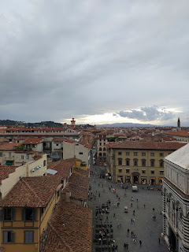

There are 3 levels on the way up the stairs where you can rest, catch your breath, and take in the views. In our case, the sun was beginning to set and a beautiful skyline began to emerge across the vast city.

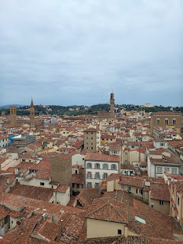

Level One - description of the Campanile (Tower) . . . (click photo to enlarge and read)

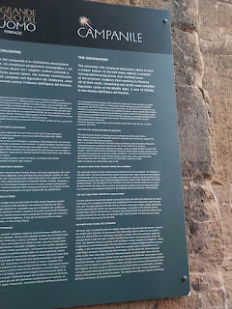

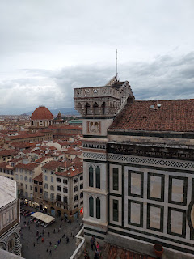

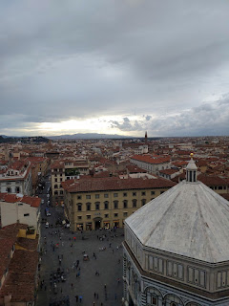

Level Two - where the old bell now sits . . .

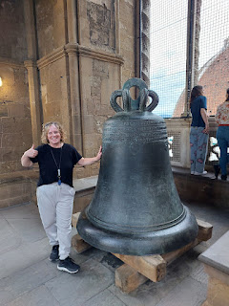

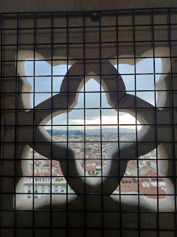

Looking all the way down to the bottom below . . .

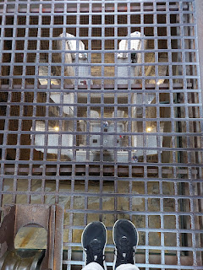

Below: A description of the bell, one of the largest to ever come out of an Italian foundry, plus some explanations as to when the bell is rung and for what purposes . . .

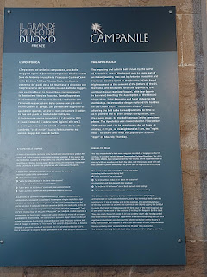

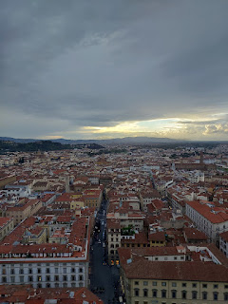

Rich and Andrea up on the very top of the Tower . . .

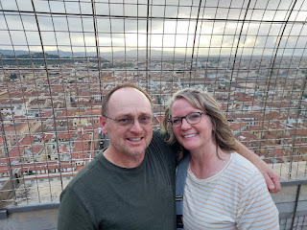

Me, with my wind-blown hair . . .

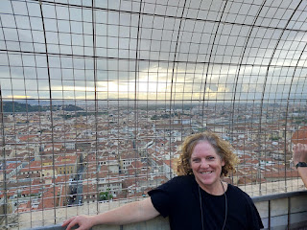

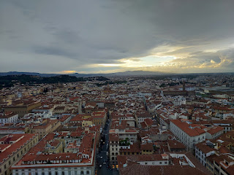

The views were so gorgeous . . .

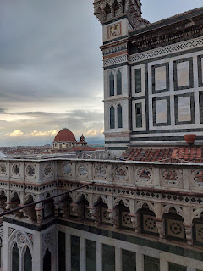

Video of the views on one side of the top of the Tower: (15 seconds)

https://photos.app.goo.gl/rxLnndp44ErCvNKK9

Video overlooking the Duomo and the chiming bells: (18 seconds)

https://photos.app.goo.gl/fyWaKhYgZZ1FSmWh6

Video of another side view through a peephole on the top: (10 seconds)

https://photos.app.goo.gl/VNYVZCHoq6fvSyuh6

Reluctantly, we headed down so we could collect our bags and tour the Duomo. Unfortunately, the guard at the entrance to the Duomo was feeling a little spicy. Even though patrons are supposed to be admitted up until 6:45 as the last entrance of the day, he decided to close up shop at 6:43 p.m. It didn't matter in the least that we had paid a fair amount for our tickets, and it didn't matter that we still had 2 minutes to be the last entries. He would not budge and was very curt and dismissive, using impatient hand gestures as he pointed to the exit.

We were pretty upset about how this turned out. If we had just been allowed to bring our minimal-sized cinch sacks up into the Tower earlier, then we could have gained an extra 10 minutes and we would have made it into the Duomo before the grumpy security guard could turn us away. This was on our bucket-list for Florence and was going to be something none of us had ever seen before. It was hugely disappointing. But what choice did we have?

We found our way around to the Baptistry to finish our tour there before it, too, closed. Weirdly, they wouldn't let us in with our cinch sacks, either. The guard suggested that we take turns going inside while someone stayed with the bags outside, saying that the tour doesn't take more than just a few minutes. I volunteered to stay with our bags while Rich and Andrea went in first. I also called my Mom while I waited so that I could wish her a happy birthday!! It was her 75th birthday on October 2nd.

We spoke for a few minutes and then Andrea came out to find me and urged me to hurry in before they closed the doors. The Baptistry would be closing in about 5 minutes! I told my mom I would call her back, and then I hurried inside. What I saw was not very impressive at all . . . I didn't even take a single photo. I think I was tired from the day, and frustrated about how things had turned out. Yes, the baptistry had some intricate carvings and artwork, but nothing really jumped out at me. It was a bunch of big signs that I had to read, and not really much of an area to explore and enjoy. Most of it was gated off and was inaccessible.

I finished my "tour" in less than 5 minutes and went outside to call my mom back. As I made my way around to Rich and Andrea, I just followed along behind them while they wandered and walked around. They found a chocolatier store where a girl was handing out free samples. I kept chatting with my mom and took a free sample and walked right back out to the street, ha ha. They found a grocery store where we could get something ahead of time for the next morning's breakfast. I stayed out front for a while, still chatting with my mom, before I eventually went inside (still talking to her) to check out their offerings in each aisle. Once we said goodbye, I made my purchase of some granola, yogurt, and a banana.

We hadn't had anything for dinner yet, so we made our way over to the nearby Central Market. This is a huge indoor "mall" of food vendors, originally opened in the late 1800's. It was a bustling place, even late at night.

I bought a Poke bowl, while Rich and Andrea found some chicken and side dishes at another booth.

Video of a vendor next to where we sat, as he slices up some pork super thinly for a sandwich: (33 seconds)

https://photos.app.goo.gl/s7YS1EcGMcbZhRwE9

Video of the bustling butcher shop on the other side of where we ate: (18 seconds)

https://photos.app.goo.gl/s7WaKjgnfiZbmryX7

Video of the animated young man that we heard shouting out numbers and orders the whole time we ate our dinner - and when I went over to take a video, he hammed it up even more: (22 seconds)

https://photos.app.goo.gl/s7f5gBiRw7qKooJQ8

On our way out of this busy and chaotic scene, we saw a cooking institute near the exit. It's called La Scuola di Cucina (The Kitchen School). It's named after Lorenzo de Medici and offers several cooking courses taught by professional chefs. It looked quiet and clean and perfect through the glass windows.

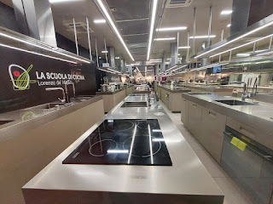

Here is a link to the classes they offer (80 euros each):

https://cucinaldm.com/en/pagina-shop/

What a busy day!! My goodness. And to think that it all started when I woke up at 3:30 a.m. and couldn't go back to sleep. I'm glad I got some rest on that long train ride though, otherwise I never would have made it.

FLORENCE (Day 2):

Don't worry . . . Day 2 was not NEARLY so full as Day 1.

Having researched our train ticket options for home the day before, we noticed that the later the hour of departure, the higher the price of the ticket got!! Like,

significantly

. So we bought tickets for an earlier-than-anticipated departure time of 1:30 p.m. We discussed what we wanted to still see and do in the few hours we had left, and prioritized the list.

After breakfast, we headed out into the rain and walked over to the Accademia Gallery. I made sure that Rich and Andrea were all set, including the exchanging of their voucher for actual tickets in hand, before I left and went on a walk. I had already been to see Michelangelo's David twice before, and therefore I opted to go on a little explore of the neighborhood while they did their tour. As it turned out, though, nothing was open that early in the morning . . .

It was pouring buckets of rain, so I ducked into the McDonald's close to the Accademia, bought some "second breakfast" (eggs and bacon), and found a quiet place downstairs to hang out for a while. I ended up staying down there for a good hour or more. I read the news on my phone, played a game or two, made an Instagram reel, and enjoyed the "nothingness". Once the store I was waiting for opened up, I walked over to it, only to be disappointed. It wasn't that the store itself was disappointing. It was a TOY STORE for goodness' sake. But it felt empty and flat because Abby and Gwen weren't there with me, like they were the last time. When we visited Florence last October together, and while Amber was in the nearby music store picking out a Christmas gift for her husband who plays the guitar, I took the girls into the toy store and we had so much fun! Grandchildren sure do bring the magic. But without them, the store had lost its lustre. I bought a simple pack of cards and then walked back over to the Accademia to wait for Rich and Andrea to come out.

They were so glad they had gotten tickets for first thing in the morning. The Accademia was so packed with people out in the street and down the street and in the plaza next door, that it was hard for us to find each other. I texted Rich to watch for my green plaid umbrella, since that was a unique identifier that nobody else had. Ultimately, I spotted them before they spotted me, and they excitedly told me about their tour and how wonderful it all was.

Our last big stop was to visit the Library and Parish of San Lorenzo: Biblioteca Medicea Laurenziana and Parrocchia di San Lorenzo. It had been raining so hard that they were handing out plastic umbrella bags at the entrance. The Italian custom is usually to place your umbrella into a basket inside whatever establishment you are going into. But the amount of people coming and going here would be a bit too much, plus our sloppy and drippy umbrellas would have been a logistical nightmare.

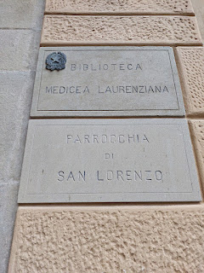

We paid a few euros to enter both the church and the library. They are adjoining, with a connecting hallway and staircase. The Parish used to be the church of the powerful Medici family, and in fact, they are now buried inside, as well as Donatello, the famous Italian artist, who was also a family friend.

Although the original church was originally built in 393 AD, the version we see today was rebuilt in 1419.  Here is a link to a really great website, with many fascinating details and history of the San Lorenzo Church:

https://www.visitflorence.com/florence-churches/san-lorenzo.html

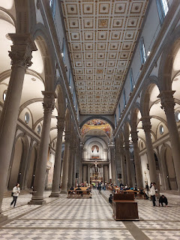

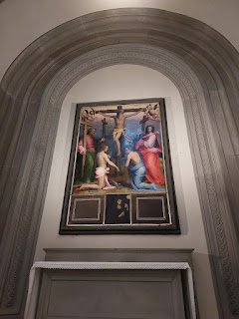

Above and below - perspectives of one of the beautiful painting that hangs in the chapel . . .

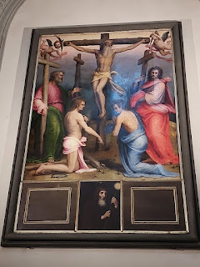

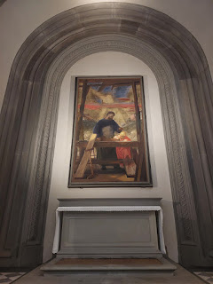

Same here - perspectives of this very moving painting. I think this was my favorite one. It shows Joseph, the earthly father of Jesus, in the workshop together. It is tender and makes me feel a lot of love for the role that Joseph played in the upbringing of our Lord and Savior.

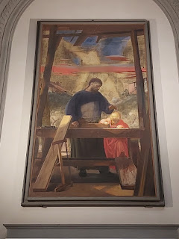

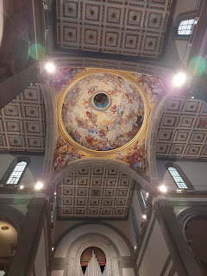

The ceiling was also extraordinary . . . very celestial and ethereal . . .

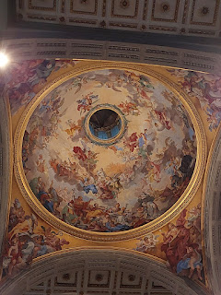

This was one of the most detailed carvings of Jesus on the Cross that I've ever seen . . .

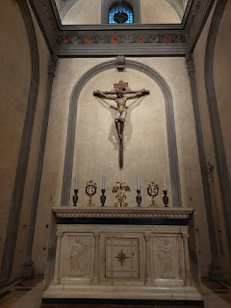

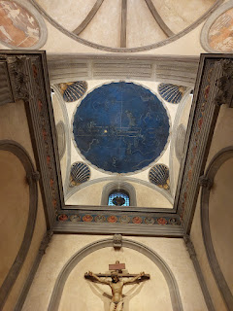

And even though I'm not a huge fan of blue, I have become obsessed with the heavenly blue of both this celestial artwork on the ceiling in Florence, and also some similar mosaic artwork in Ravenna's basilicas. (I will share more about that in a different post soon.)

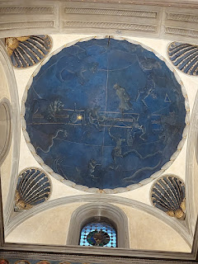

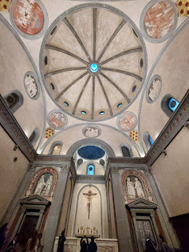

Above and below: With Jesus as the focal point, He is complimented by a series of geometric shapes that are meant to expand our spiritual understanding of God and the Heavens, as both He and the Heavens in which He resides are expansive and eternal.

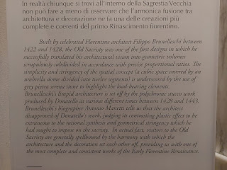

I didn't know at first what this sculpture was all about. All I knew was that I loved it.

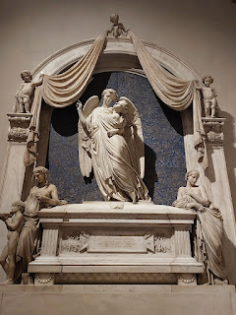

Essentially it is a memorial to the wife of a Count, who died very young at the age of 26. She is referred to as beautiful and virtuous.

And I really loved this sculpted portion below the memorial above, that conveys the love of Jesus' parents, but more especially that of His mother, Mary. She radiates joy and happiness, probably for the miracle of what happened AFTER His terrible death.

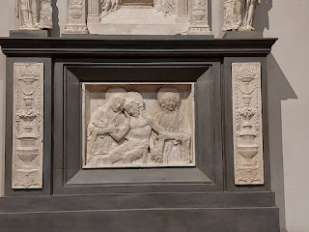

The chapel certainly had a lot of beautiful artwork, and I guess that is to be expected since it was all for the Medici Family.

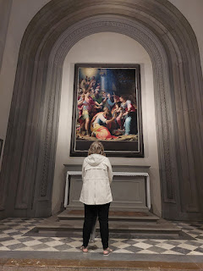

I asked permission from this young man if I could take a photo of his artwork. He happily agreed. He was one of several students who were there as part of a local art class . . .

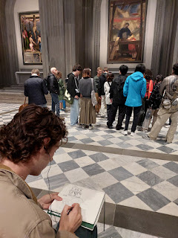

Next, we went over to the adjacent Library of the Medici Family . . .

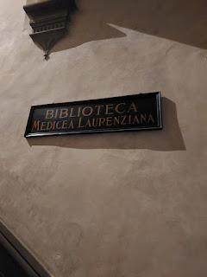

Something that is mentioned in the link above (for the San Lorenzo Church) is that the Medici Family wanted everyone to know that they weren't just political figures, they were EDUCATED and SCHOLARLY. Thus, they filled their library with thousands and thousands of manuscripts and books, which are still housed there today.

Video looking into the cloister below from the balcony, just outside the library entrance: (7 seconds)

https://photos.app.goo.gl/uM19fVJXHXYzxPrQA

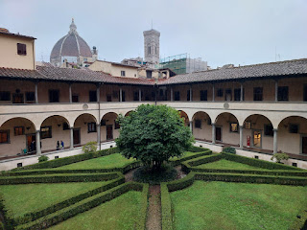

Something special about this Library is that Michelangelo was brought here to design and build some of its features. He wasn't able to finish the project in its entirety because he was called off to Rome, but scholars have said that the staircase that he designed was an exceptional masterpiece.

(Click photos below to read more)

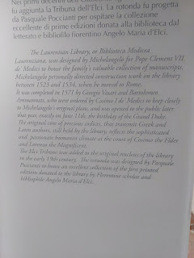

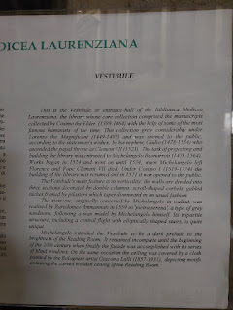

While Michelangelo did not build these steps himself, he designed them and someone else carried out his original plans.

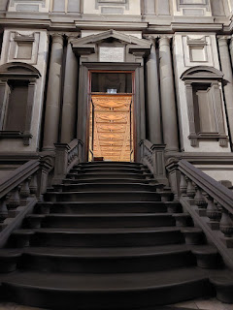

They are seriously impressive . . .

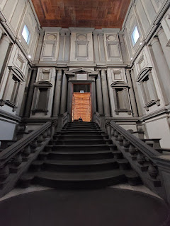

The Reading Room is magnificent, too, with its length, the detail work in the ceiling's art, and really just everything . . .

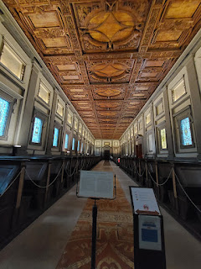

Sorry that this next sign is slightly blurry - but it's still readable . . . it describes the Reading Room.

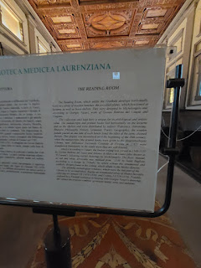

We weren't allowed to walk in the middle of the long aisle . . . we could only walk where the carpet was provided so that the original flooring could be preserved.

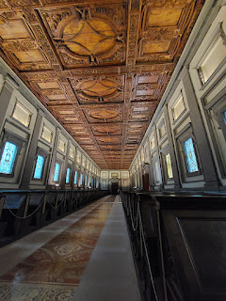

The guide seated at the door came over to talk to us for a bit, as he overheard us asking questions. On the stained glass windows are several astrological references to the members of the Medici Family, including Capricorns . . .

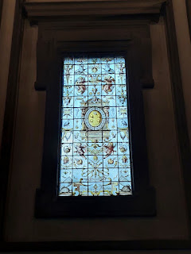

Capricorns are also found in each of the ceiling panels  . . .

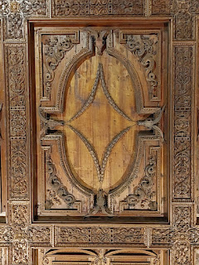

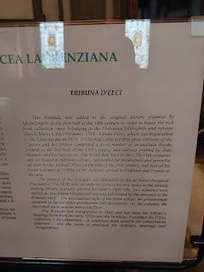

Above and Below: A description of - and a photo of - the Rotunda, a room that extends off to the side of the great Reading Room. We could not enter the Rotunda - it was roped off. But it sure was pretty.

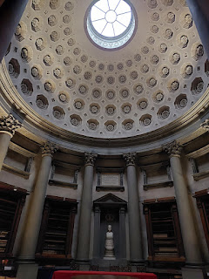

I didn't know this when I took the photos, but I later learned that each bench in the Reading Room has inscriptions that indicate what books and manuscripts are housed inside each one. That is some sweet (and secret) storage space!

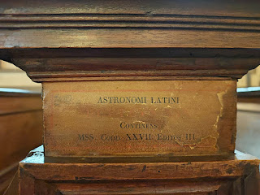

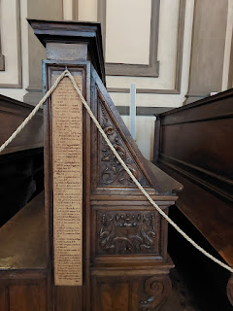

It was time to head to the train station and make our way home to Vicenza. We gathered our things back at the AirBnB and made our way through the pouring rain once again. It was about a 25 minute walk this time because of the unsavory weather and the throngs of people holding umbrellas.

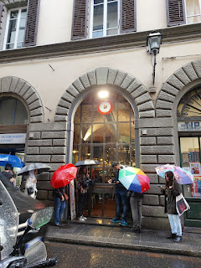

This last picture says it all . . . LOL

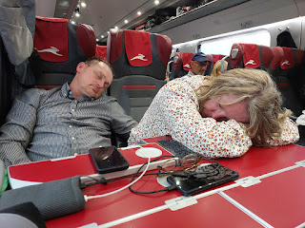

This time we were able to negotiate with some college-aged men so that they could all sit together across the aisle, and we could all sit together, too. How nice. Our tickets originally had us here, there, and everywhere.

The train ride home was smooth, fast, and event-free. Scott picked us up on the other end and we had a perfectly relaxing evening together at home.